**How To Convert the DateTime to String**

Different business processes may required different DateTime formats.

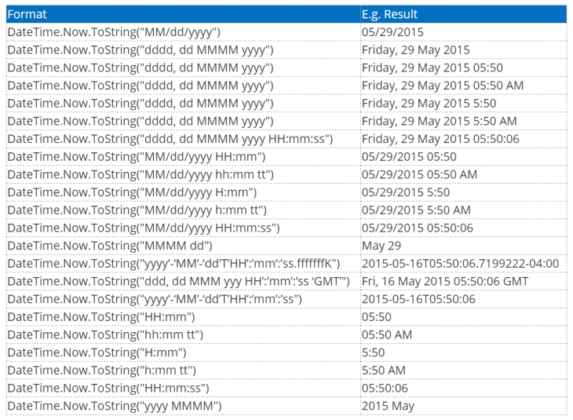

1. d >> Represents the day of the month i.e 1,2,16 or 31
2. dd >> Represents the day of the month i.e 01,05,14 or 31
3. ddd >> Represents the abbreviated name of the day i.e Mon, Tues or Wed
4. dddd-> Represents the full name of the day i.e Monday, Tuesday or Wednesday
5. M >> Represents the month number i.e 1,5 or 12
6. MM >> Represents the month number with leading zero i.e 04,09 or 12
7. MMM >>Represents the abbreviated month Name i.e Jan, May or Dec
8. MMMM >> Represents the full month name i.e. January, June or December
9. y >> Represents the year i.e. 2019 as 19
10. yy >> Represents the year with a leading zero i.e. 2019 as 019
11. yyy >> Represents the year i.e 2019
12. yyyy >> Represents the year i.e 2019
13. h >> Represents the 12-hour clock i.e 4,11 or 2
14. hh >> Represents the 12-hour clock with a leading 0 i.e. 04,05 or 12
15. H >> Represents the 24-hour clock i.e 13,18 or 22
16. HH >> Represents the 24-hour clock with a leading 0 i.e. 04,09 or 22
17. m >> Represents the minutes i.e. 12,40 or 56
18. mm >> Represents the minutes with a leading zero i.e 04,09 or 23
19. s >> Represents the seconds i.e 9,35 or 40
20. ss >> Represents the seconds with leading zero i.e. 04,09 or 35